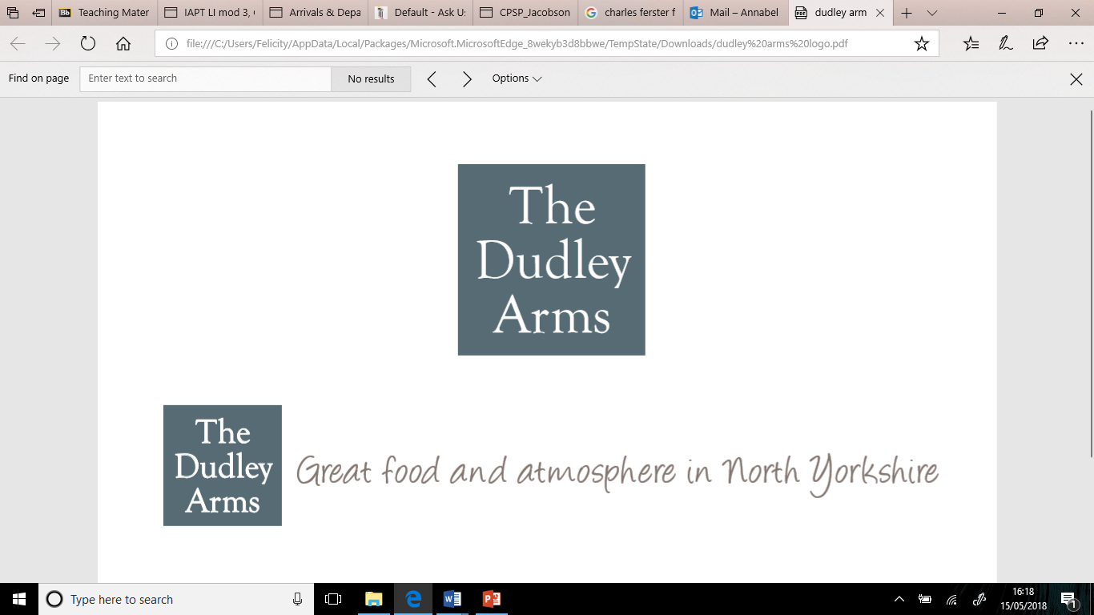

**August Lunch & Early Evening  
Monday- Saturday  
Lunch 12.00pm-2.00pm & 5.00pm-7.00pm**

**Lasagne with Salad 2 for £8.00**

**Lasagne with Salad £5.50**

**Chilli, Rice & Tortilla Crisps £5.00**

**Arrabbiata Game Meatballs with Spaghetti £6.50**

**Penne Pasta with Pork, Mushroom & Red Wine Ragu £6.00**

**Steak Sandwich, Chips & Salad £6.50**

**Freshly Battered Cod & Chips (gluten free batter available) £6.00**

**Chicken Parmesan, Chips & Salad £8.00**

**Scampi, Chips & Salad £7.50**

**Steak board, Chips, Salad & Coleslaw £10.95**

**SIDE DISHES**

**HOMEMADE CHIPS ~ £1.30  
COLESLAW ~ £1.60  
HOUSE SALAD ~ £1.50   
ANGELIQUE (BBQ) DIP ~ £1.10  
AIOLI (GARLIC DIP) ~ £1.10  
GARDEN PEAS ~ £1.00  
MUSHY PEAS ~ £1.00  
GARLIC BREAD ~ £1.50  
VEGETABLES ~ £1.50  
ONION RINGS ~ £2.60**

**This menu cannot be used in conjunction with our loyalty cards**

**THIS MENU SERVED IN THE BISTRO AND BAR ONLY**

